**Priority Scheduling-**

In Priority Scheduling,

* Out of all the available processes, CPU is assigned to the process having the highest priority.
* In case of a tie, it is broken by [**FCFS Scheduling**](https://www.gatevidyalay.com/first-come-first-serve-cpu-scheduling/).

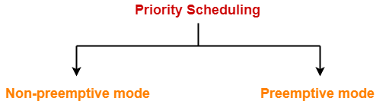

* Priority Scheduling can be used in both preemptive and non-preemptive mode.

**Advantages-**

* It considers the priority of the processes and allows the important processes to run first.
* Priority scheduling in preemptive mode is best suited for real time operating system.

**Disadvantages-**

* Processes with lesser priority may starve for CPU.
* There is no idea of response time and waiting time.

**Important Notes-**

**Note-01:**

* The waiting time for the process having the highest priority will always be zero in preemptive mode.
* The waiting time for the process having the highest priority may not be zero in non-preemptive mode.

**Note-02:**

* Priority scheduling in preemptive and non-preemptive mode behaves exactly same under following conditions-The arrival time of all the processes is same.
* All the processes become available

**PRACTICE PROBLEMS BASED ON PRIORITY SCHEDULING-**

**Problem-01:**

Consider the set of 5 processes whose arrival time and burst time are given below-

|  |  |  |  |
| --- | --- | --- | --- |
| **Process Id** | **Arrival time** | **Burst time** | **Priority** |
| P1 | 0 | 4 | 2 |
| P2 | 1 | 3 | 3 |
| P3 | 2 | 1 | 4 |
| P4 | 3 | 5 | 5 |
| P5 | 4 | 2 | 5 |

If the CPU scheduling policy is priority non-preemptive, calculate the average waiting time and average turn around time. (Higher number represents higher priority)

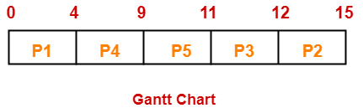

**Solution-**

**Gantt Chart-**

Now, we know-

* Turn Around time = Exit time – Arrival time
* Waiting time = Turn Around time – Burst time

**Also read-** [**Various Times of Process**](https://www.gatevidyalay.com/turn-around-time-response-time-waiting-time/)

|  |  |  |  |
| --- | --- | --- | --- |
| **Process Id** | **Exit time** | **Turn Around time** | **Waiting time** |
| P1 | 4 | 4 – 0 = 4 | 4 – 4 = 0 |
| P2 | 15 | 15 – 1 = 14 | 14 – 3 = 11 |
| P3 | 12 | 12 – 2 = 10 | 10 – 1 = 9 |
| P4 | 9 | 9 – 3 = 6 | 6 – 5 = 1 |
| P5 | 11 | 11 – 4 = 7 | 7 – 2 = 5 |

Now,

* Average Turn Around time = (4 + 14 + 10 + 6 + 7) / 5 = 41 / 5 = 8.2 unit
* Average waiting time = (0 + 11 + 9 + 1 + 5) / 5 = 26 / 5 = 5.2 unit

**Problem-02:**

Consider the set of 5 processes whose arrival time and burst time are given below-

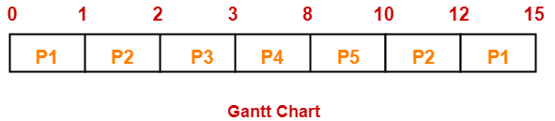

|  |  |  |  |
| --- | --- | --- | --- |
| **Process Id** | **Arrival time** | **Burst time** | **Priority** |
| P1 | 0 | 4 | 2 |
| P2 | 1 | 3 | 3 |
| P3 | 2 | 1 | 4 |
| P4 | 3 | 5 | 5 |
| P5 | 4 | 2 | 5 |

If the CPU scheduling policy is priority preemptive, calculate the average waiting time and average turn around time. (Higher number represents higher priority)

**Solution-**

**Gantt Chart-**

Now, we know-

* Turn Around time = Exit time – Arrival time
* Waiting time = Turn Around time – Burst time

|  |  |  |  |
| --- | --- | --- | --- |
| **Process Id** | **Exit time** | **Turn Around time** | **Waiting time** |
| P1 | 15 | 15 – 0 = 15 | 15 – 4 = 11 |
| P2 | 12 | 12 – 1 = 11 | 11 – 3 = 8 |
| P3 | 3 | 3 – 2 = 1 | 1 – 1 = 0 |
| P4 | 8 | 8 – 3 = 5 | 5 – 5 = 0 |
| P5 | 10 | 10 – 4 = 6 | 6 – 2 = 4 |

Now,

* Average Turn Around time = (15 + 11 + 1 + 5 + 6) / 5 = 38 / 5 = 7.6 unit
* Average waiting time = (11 + 8 + 0 + 0 + 4) / 5 = 23 / 5 = 4.6 unit

To gain better understanding about Priority Scheduling,